Sennheiser returns to ABTT with full range of theatre focussed products: Audio specialist shows Digital 6000, MKE, HSP and new in ear monitors series at UK theatre show

Marlow, May 31st, 2019 – Sennheiser is set to return to this year’s ABTT with a raft of products, including its smallest ever bodypack transmitter, the new SK 6212, that are sure to delight the theatre industry. Held at Alexandra Palace on the 5th and 6th of June, ABTT is the UK’s only trade show dedicated to the country’s burgeoning theatre market and Sennheiser’s stand will be packed with the company’s theatre focussed ranges, including the full Digital 6000 Series, the MKE and HSP families and the new IE 40 PRO, IE 400 PRO and IE 500 PRO in-ear monitoring headphones.

Part of the Digital 6000 Series is Sennheiser’s highly anticipated, ultra-compact SK 6212 bodypack transmitter, which is compatible with both Digital 6000 and Digital 9000 systems. At only 63 x 47 x 20mm, the SK 6212 as small as a matchbox, weighs just 112g, and achieves a guaranteed 12 hours of operation on one battery charge.

The SK 6212 has found instant favour with the UK productions of Come From Away at the Phoenix Theatre in London’s West End and the touring production of The Bodyguard, both of which have benefited greatly from the SK 6212’s diminutive size and incredible battery life.

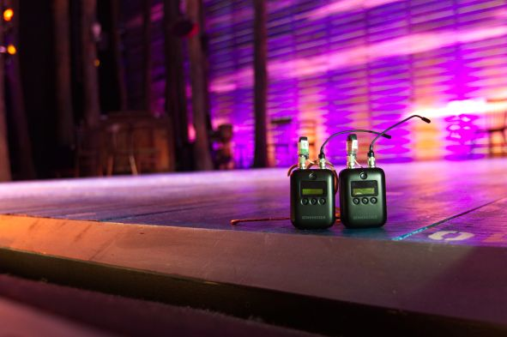 | The SK 6212 takes centre stage at the Phoenix Theatre for Come From Away. The digital mini-bodypack transmitter is as small as a matchbox at only 63 x 47 x 20mm, and weighs just 112g

“The holy grails of radio mics for musical theatre are invisible packs and invisible microphones,” says sound designer for Come From Away, Gareth Owen. “We already knew that the Sennheiser digital radio systems were a big step up in quality. Now we have the first ever transmitter small enough that you don’t get into an argument when you say you want to use two radio mics on a show – and it’s got a battery life that means we don’t have to change batteries between shows.”

“The SK 6212 has the signature sound that I would expect from Sennheiser, but it’s in a much smaller package,” adds Richard Brooker, sound designer on The Bodyguard. “And the battery life really is unbelievable. Sennheiser claimed it would do 12 hours, and it does!”

With the SK 6212 fulfilling musical theatre’s first holy grail, the second is addressed by Sennheiser’s ranges of headworn, neckworn and clip-on microphones from the MKE and HSP families.

The MKE1 is Sennheiser’s smallest professional clip-on mic, which delivers a full, natural sound, high speech intelligibility in a very sweat-resistant package courtesy of its protective membrane.

The MKE 2 is a high-quality, sub-miniature omni-directional clip-on lavalier microphone that fulfils the highest demands on sound quality and ruggedness and is sweat protected by special ultralight Umbrella Diaphragm™.

The MKE Essential Omni (omnidirectional) is designed for demanding everyday use on live stages. The newly developed KE 4 capsule is derived from the Broadway standard MKE 2, with improvements that provide a warm and distortion-free signal, even at high sound pressure levels.

In the HSP family, the HSP Essential Omni neckworn microphone gives weight to your voice. Inconspicuous and lightweight, it guarantees comfort, even when worn for extended periods.

The HSP2 is a high-quality condenser omni-directional neckband mic for vocal and speech applications that is individually adjustable and comes with a patented sweat-protected diaphragm. Components are easily interchangeable and combinable thanks to the HSP2’s modular design.
The HSP Essential Omni | 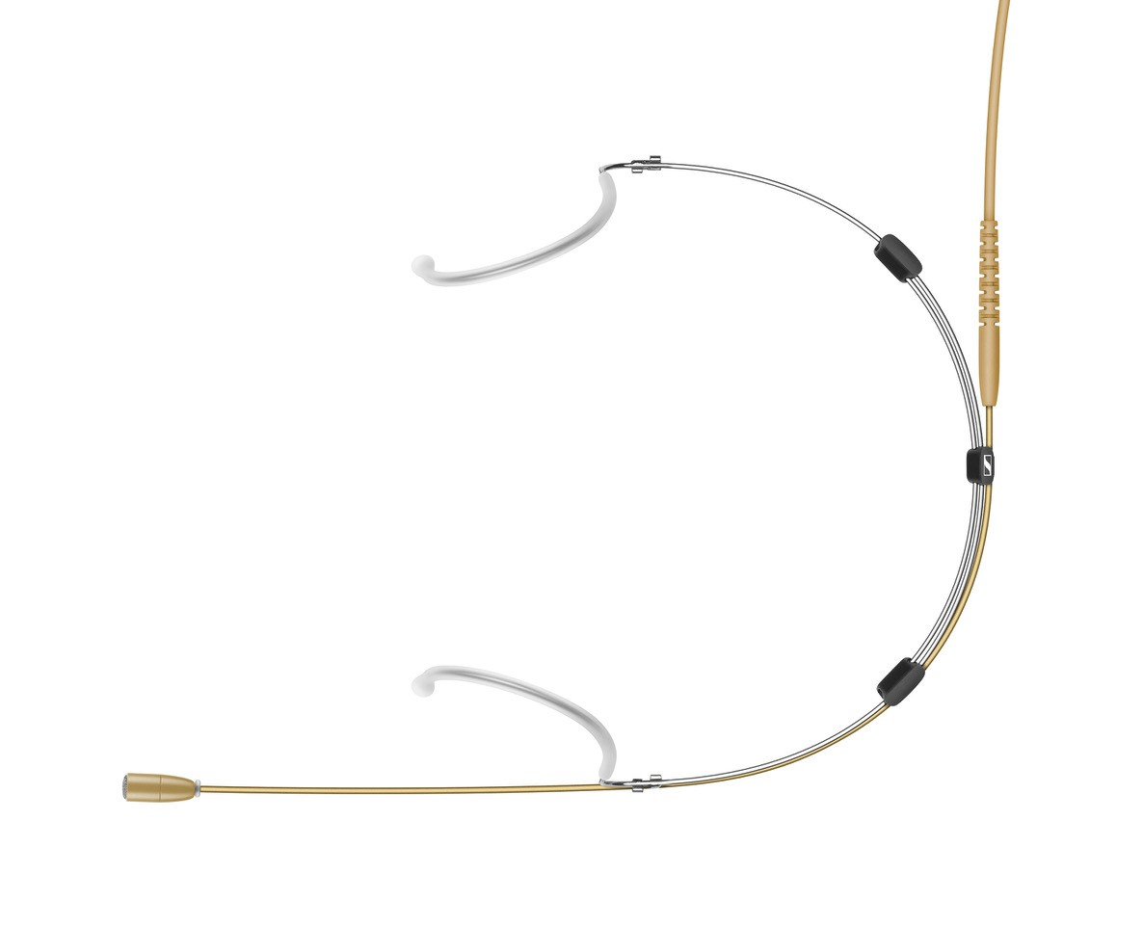

The final Series in Sennheiser’s theatre arsenal is the brand-new IE PRO Series, which includes the IE 40 PRO, IE 400 PRO and IE 500 PRO.

The entry-level IE 40 PRO is the first in this brand-new series of professional in-ear monitors. It ensures impeccable audio reproduction with warmth, great detail and natural clarity, improving the artist’s focus and performance control, even in difficult stage situations, which is complemented by a well-thought-out mechanical design that includes a patent-pending, break-proof cable ducting.

The latest additions to the family are the IE 400 PRO and IE 500 PRO, both offering natural, high-resolution sound, a secure and comfortable fit that comes close to custom-moulded in-ears and a break-proof, patent-pending cable connection.

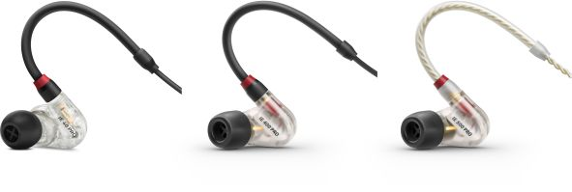 | The IE in-ear range (L>R):  The IE 40 PRO, IE 400 PRO and IE 500 PRO

This single-driver technology, termed TrueResponse, ensures a completely natural, clear and spacious sound stage with a total harmonic distortion (THD) as low as under 0.08% at 1 kHz and 94 dB. When the sound is so precise and detailed, the acoustical stress for the wearer is reduced, allowing them to set their monitors to a lower level.

With the driver measuring only 7 mm in diameter, the IE 400 PRO and IE 500 PRO feature a comfortable ear mould, which is ergonomically shaped, has a low profile and is extremely lightweight.

Like every in-ear in this professional series, the IE 400 PRO and IE 500 PRO are fitted with a break-proof inner cable duct (patent pending), that has the cable’s sturdy anti-kink sleeve sit directly on the ear mould, providing a long-lasting solution for the rigors of stage use.

Sennheiser is delighted to show this comprehensive range of theatre solutions on Stand O2 at ABTT, with Sennheiser partners Blitz and Autograph Sales & Installations will also be showing a number of Sennheiser solutions on their stands, including Digital 6000 Series with the SK 6212 bodypack.

About Sennheiser
Shaping the future of audio and creating unique sound experiences for customers – this aim unites Sennheiser employees and partners worldwide. Founded in 1945, Sennheiser is one of the world’s leading manufacturers of headphones, microphones and wireless transmission systems. With 21 sales subsidiaries and long-established trading partners, the company is active in more than 50 countries and operates its own production facilities in Germany, Ireland, Romania and the USA. Since 2013, Sennheiser has been managed by Daniel Sennheiser and Dr. Andreas Sennheiser, the third generation of the family to run the company. In 2017, the Sennheiser Group generated turnover totaling €667.7 million. www.sennheiser.com

Local press contacts

Sarah James Victoria Chernih
sarahj@gasolinemedia.com.com victoria.chernih@sennheiser.com
+44 1483 223333 +44 7881 091687

